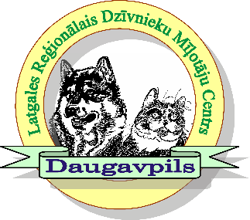

Latgales reģionālais Dzīvnieku mīļotāju centrs
Show place : Višķu tehnikums, “Estrāde”, Višķu pagasts, Augšdaugavas novads.
- ​29.06.2024 / National Dog Show “ SUMMER IN LATGALE ”
- 30.016.2024 / National Dog Show ” BLUE LAKE LAND CUP 2024”

GUARANTEE LETTER

I _______________________________________________________, place of residence
(legible full name, surname, passport No)
_________________________________________________________________________
(legible full address, phone, e-mail)

undertake to pay the registration fee for my dog(s) in full at the entrance to Daugavpils National Dog shows / Latgales Regional club , or partly in the cases specified in the Latvian Cynological Federation Regulations for dog shows (dog’s death or illness etc., which should be confirmed by a veterinarian’s statement), in the amount of ___________ EUR, regardless of any circumstances. The payment is guaranteed even in the case of not coming to the dog show.

Nr. | Breed | Dog name | Pedigree number | EUR
1
Summary:

_________________________________________________________
(Date , signature )

